**

**Contents**

1. Connection Form: 1

2. Enter Data Form: 4

3. Mixed Palletizing Form: 6

# Connect to the controller:

You must choose the controller that you want to connet before click ***Connect to Controller Button***

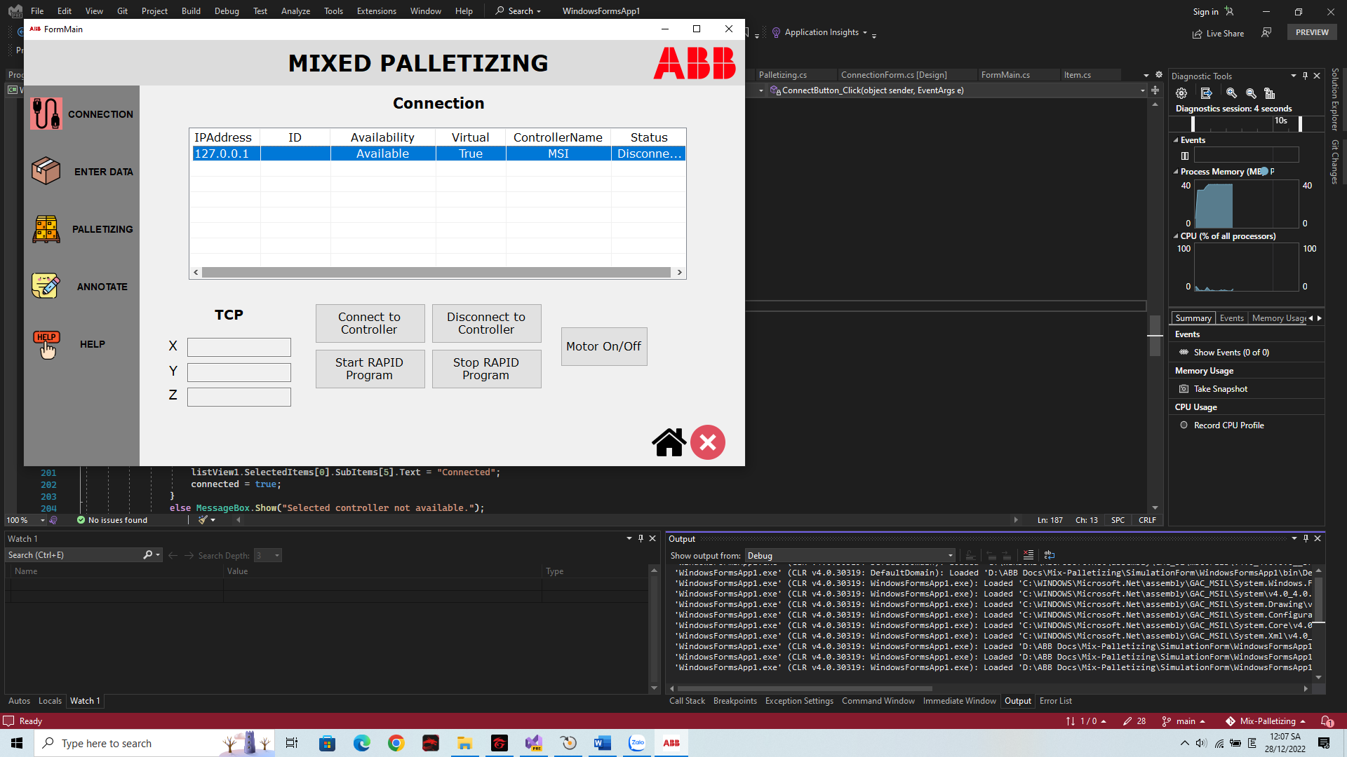

Otherwise it will be error.

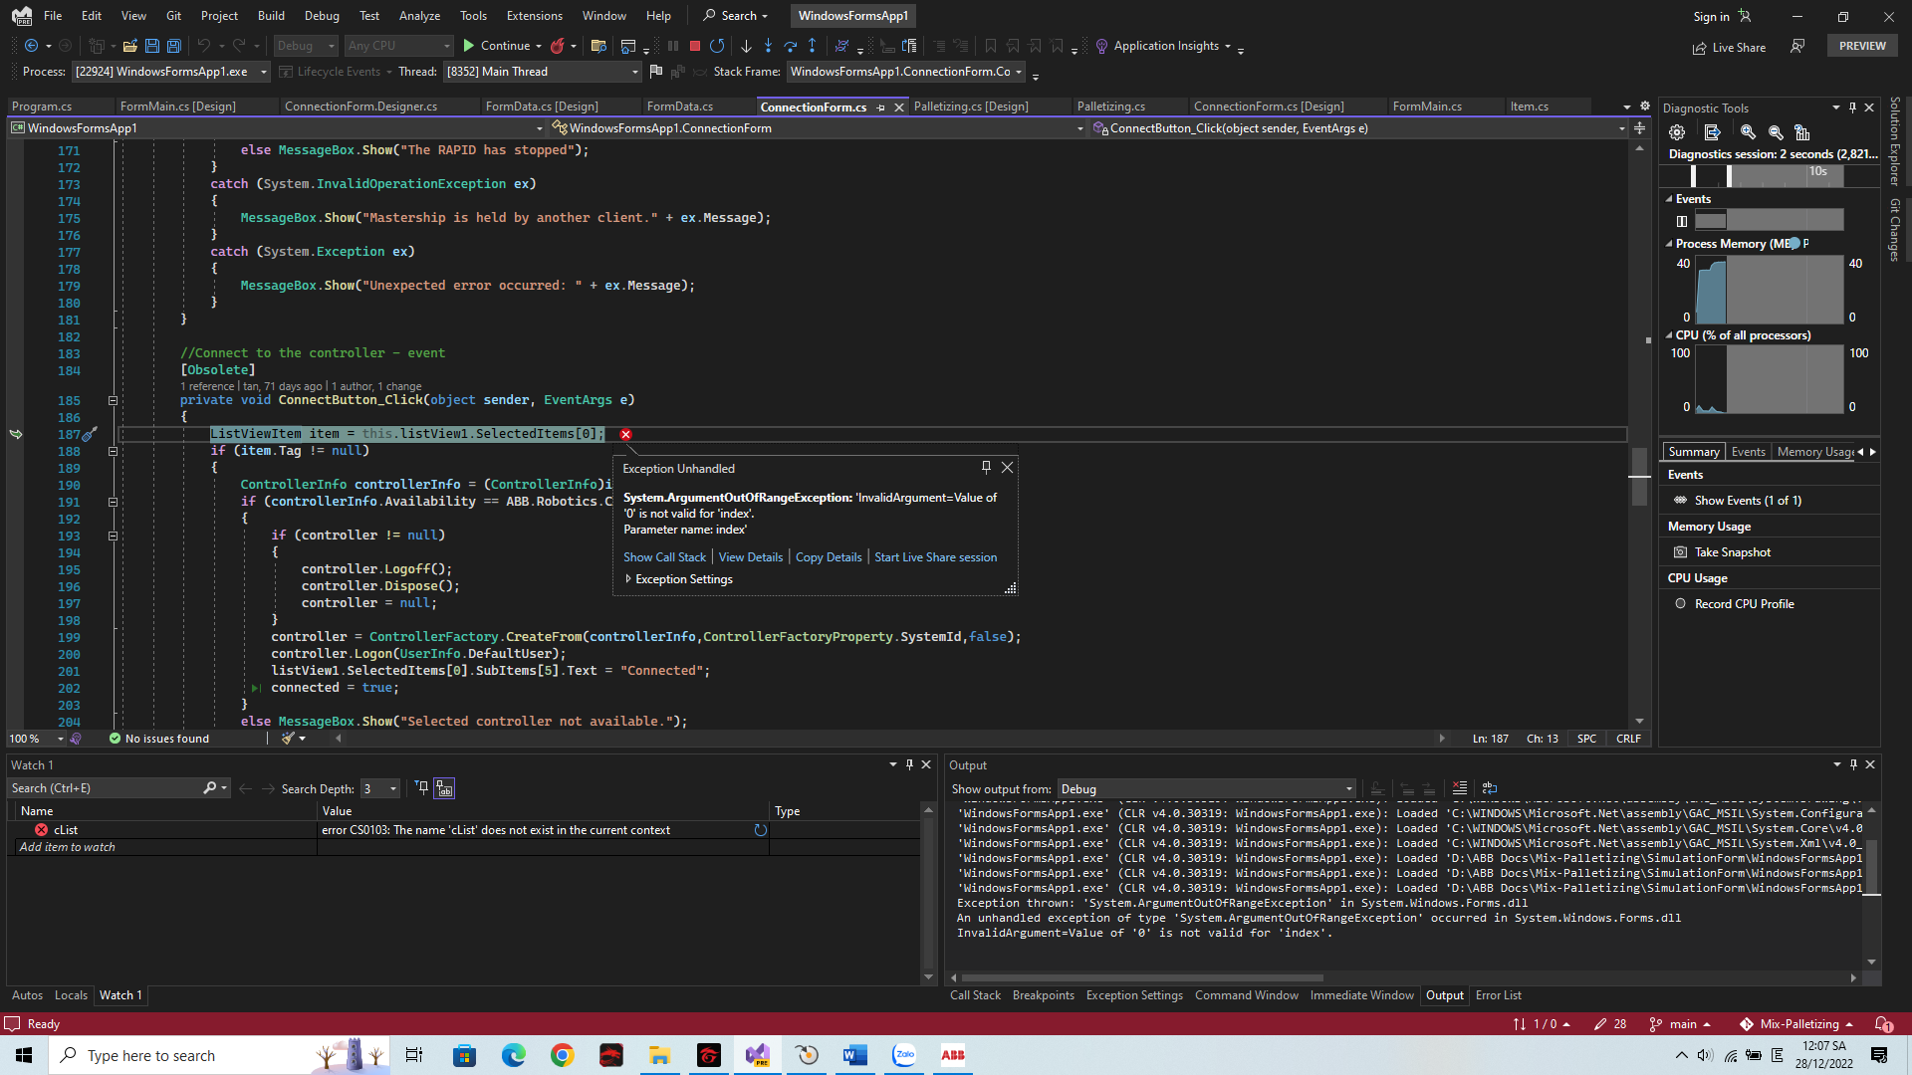

# If you sent target, you couldn’t change the data of boxes:

When you click solve and send data, you can’t change size of box in the ***Enter Data Form***.

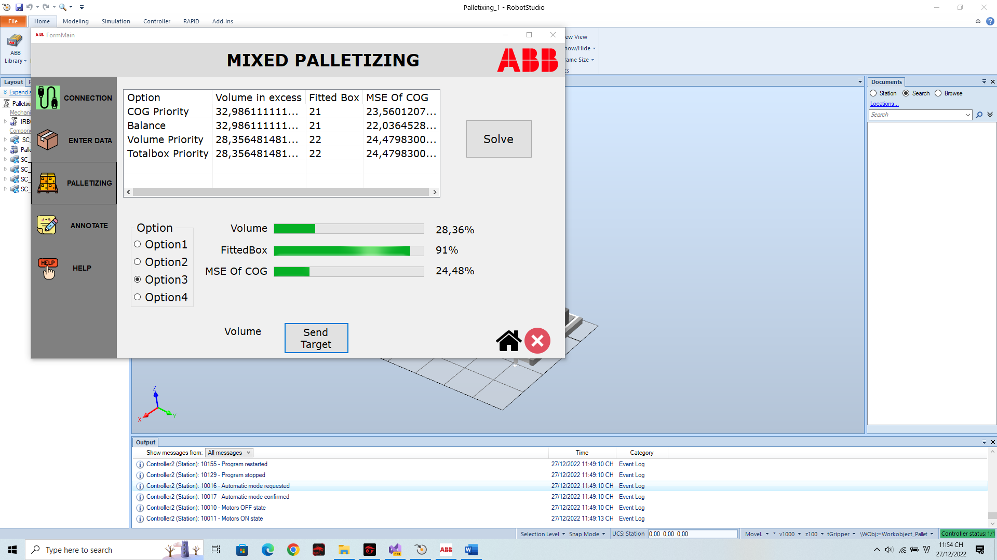

If you change the data you will see the error blow

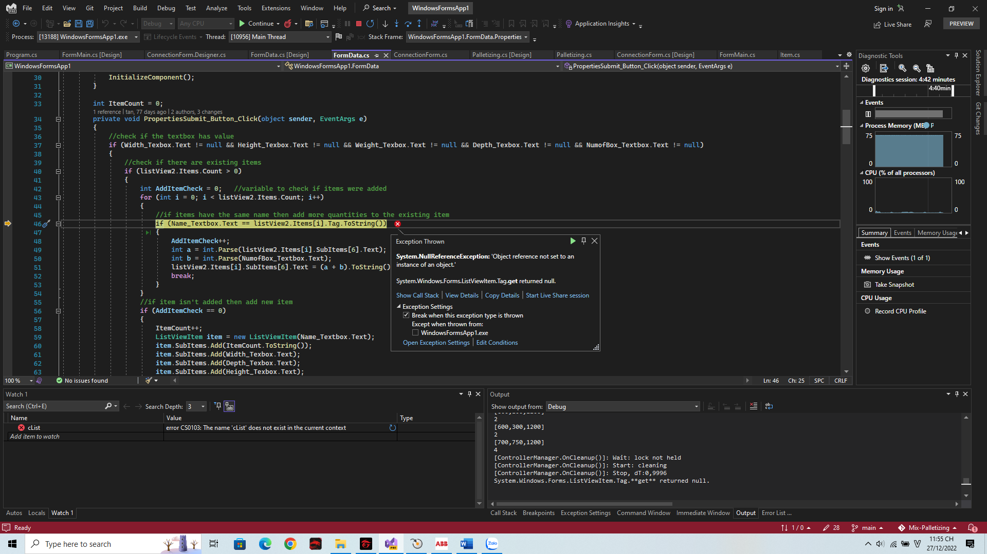

. You must turn off the form and run again.

# Robot’s arm out of range

Due to the lack of time, we didn’t change the layout. So when you see the program stop suddenly, It’s was robot out of range. You must reset in the simulation tab.

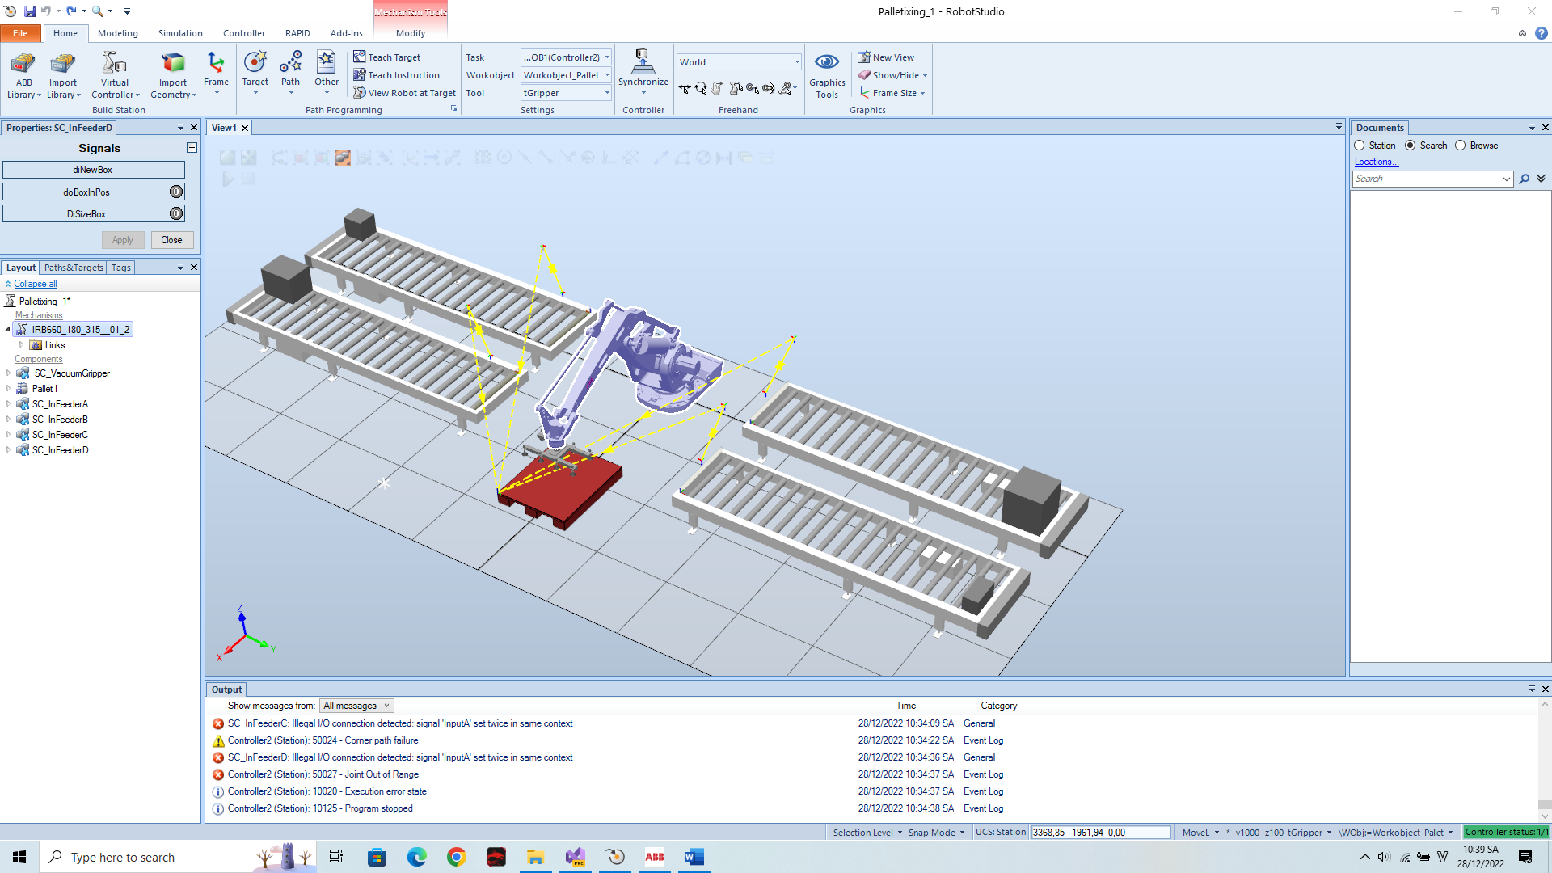

# Run again

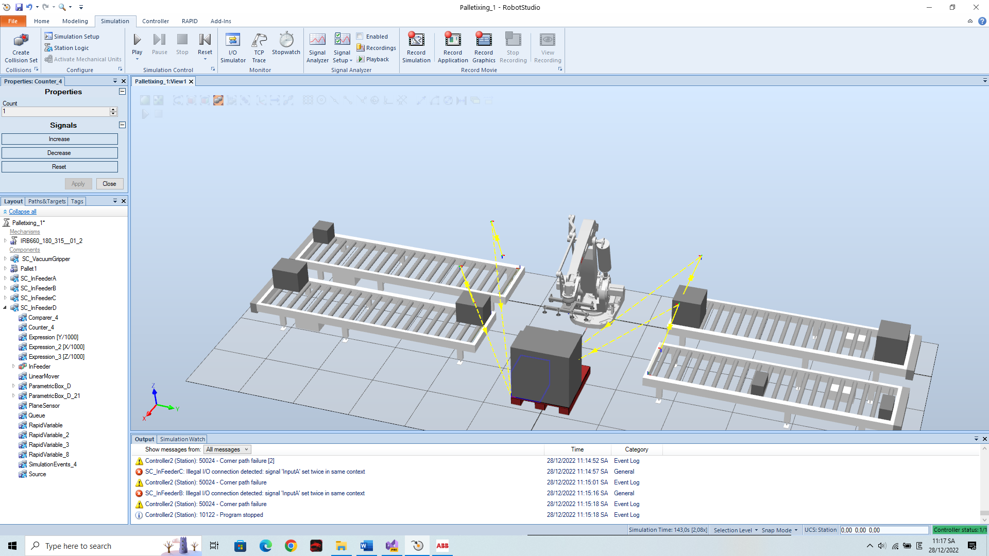

When robot packs finish, if you want to pack again you can click reset in the simulationtab and send target again.